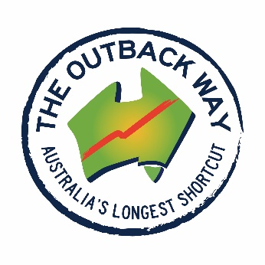

MEDIA RELEASE

SEALING AUSTRALIA’S ‘LONGEST SHORT-CUT’- A NATIONAL VISION

Today in Laverton WA- Hon. Mike McCormack- Deputy Prime Minister, Minister for Infrastructure announced the next 310km of sealing projects for the Outback Way, the 2,720 kilometres highway from Laverton, Western Australia to Winton, Queensland- linking Perth to Cairns.

These projects are priorities within the Outback Way Investment Strategy and are funded by the $160Million announced in the 2018 Budget.” said Mr Patrick Hill – Chairman Outback Highway Development Council Inc. (OHDC Inc) .

“The OHDC Inc welcomes the $330million investment from the Australian Government to date for the Outback Way and acknowledged the additional 20% contribution and works done by WA, Qld & NT governments, taking the total investment to $400million since 2014” Mr Hill said.

“From the combined funding- Western Australian section of the route would receive a further $95.5 million and seal 155km, the Northern Territory section receiving a further $62.5 million and seal 97.25km and the Queensland section a further $42million and seal 58.7km - in total 310.95km will be sealed or widened.” Mr Hill said.

Outback Highway Development Council Chairman Patrick Hill said ‘the investment will improve the standard of the road reduce travel times, cut freight costs and closures for critical regional industries such as mining, Ag and tourism, and improve road safety across the route.”

“The sealing of the Outback Way improves community access, supports economic development across the region and more reliable access to health and education services for remote indigenous communities,” Mr Hill said.

“This is an essential project for Australia with these rolling projects and funding - this trans-national project is becoming a reality.” Mr Hill said.

For more information on the Australian Government’s Outback Way investments, visit https://investment.infrastructure.gov.au/infrastructure_investment/outback_way.aspx.

ENDS>>>>
Patrick Hill 0419925371 Helen Lewis 0418785285

